Proposed Project Plan

Project Name: ExerciseMachine

Developers: Camila Romero & Sunday Onwuchekwa

Class: CIT 260: Object-Oriented Programming – winter 2020

Brigham Young University – Idaho

**Executive Summary**

ExerciseMachine allows unauthenticated users to use various types of gym equipment to keep fit and check the number of calories burned. The users will choose equipment of choice, add the time they spend using the equipment, and their weight prior to using the equipment. The system will then create a MET (Metabolic equivalent for the task) according to the equipment selected and generate the number of calories burned.

**Requirements**

The following are the requirement for the proposed system:

* The project allows unauthenticated users to check the calories burned after the use of equipment of choice for exercise.
* User data, such as name, weight, equipment used, and exercise time, will be loaded into a text file named, “exercise_data.txt”.
* The project should not allow negative value for user weight. The weight should be in kilograms.
* It should also accept user time spend in minutes. For example 120 minutes instead of 2 hours. The project should not allow negative values for time spend.
* The following are the type of possible equipment will be available for each user: Treadmill, elliptical, and stationary bikes. They should inherit the characteristic of the MachineObject class.
* The project should validate input for name, weight, time, and equipment. It should throw an exception if there are invalid data. The program should continue to prompt the users for correct input if they select or enter wrong inputs.
* The project should calculate the total calories burned and display the report to the user.

**User Stories**

As a **user**, I want to be able to:

* Enter my name
* Select an exercise machine
* Enter the exercise time in minutes
* Enter my weight in kilograms

As a **system**, it must:

* Accept valid data provided by the user
* Creates a machine object
* Creates a MET (Metabolic equivalent for the task) according to the object selected
* Add the MET, time, and weight to the ‘’Calories burned’’ formula.
* Add user’s data to an array of object.
* Write to and read from a file the data entered and selected by the user.
* Add the retrieved date to an array of Object, calculate total calories burned, and get the report from the formula
* Tell the user how many calories burned based on the object and the formula and output a goodbye message

**User Interface Design**

The project will use a non-graphical text terminal (console) based GUI. The system will display prompts for users to enter or select the required information. To choose a gym equipment, the user will use option keys 1, 2, or 3: for Elliptical, Stationary Bike, or Treadmill respectively. The user will also have to press the enter key after answering a prompt to continue.

**UML Class Design**

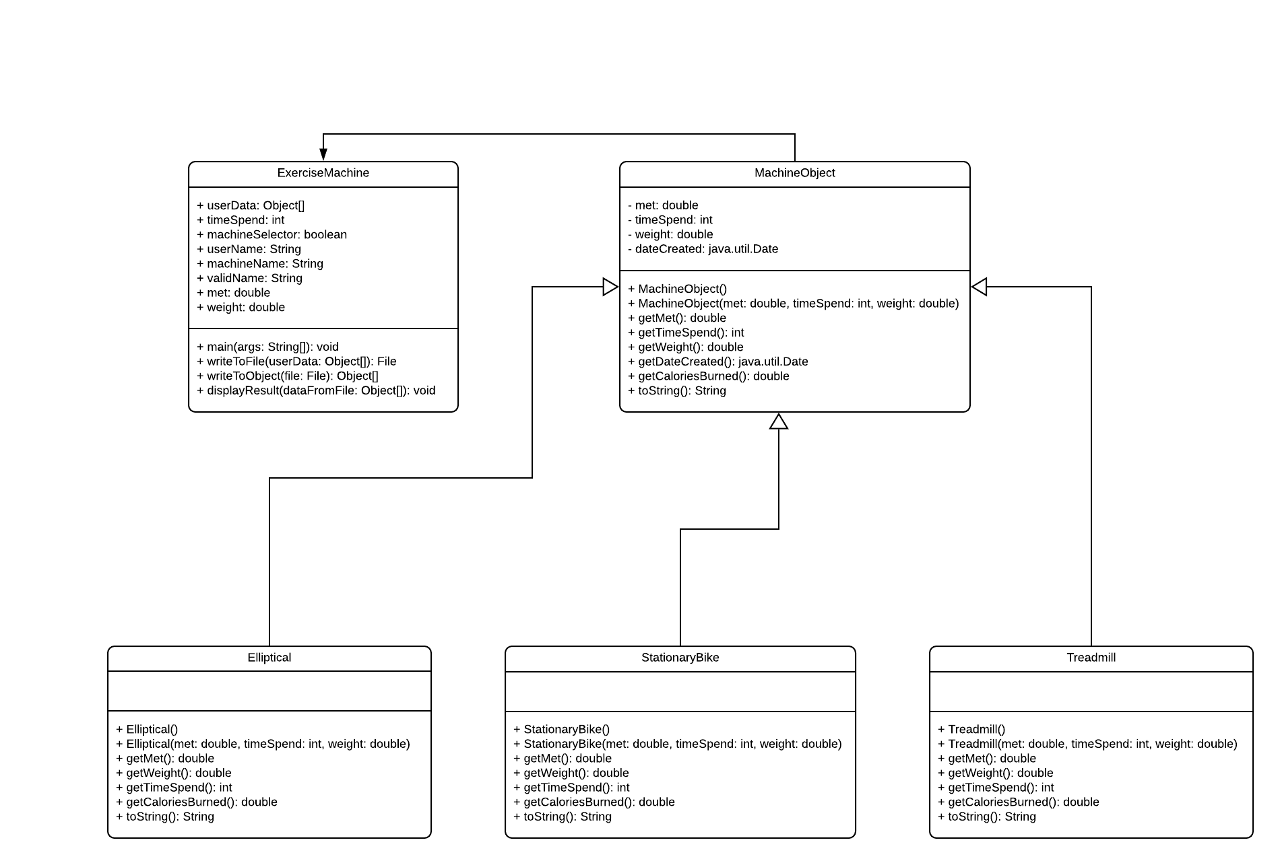

UML Link: <https://www.lucidchart.com/invitations/accept/bbb98e28-c84f-4e61-8fe8-65d8ff7b6f6a>